HOW SOA IMPLEMENTATION ADDS VALUE TO A BUSINESS
The SOA Solution : Turning Software Applications into building blocks that can be infinitely rearranged at great speed.
Not only is business reconfigured but also there is the connection to suppliers, partners and customers.
SOA puts IT in the hands of business executives who direct it to create the most value.
There is improved flexibility and decreased costs.
SOA brings about business innovation.
THE CHALLENGES
IBM’s simplified approach can be used in measuring the business value of SOA.
Measuring SOA success is a business requirement in today’s organization.
Quantifying SOA Success
Shared-Service Consumers : A valuable metric ;
Cost to maintain shared services
Web-services adoption;
Business Responsiveness;
Cost to maintain a single-purpose service;
cost to maintain a service built by someone else.
Single-purpose service cost = Shared service cost only @ effective SOA implementation.
SOA is structured to control cost of INTEGRATION
Examples on SOA implementations adding value to business
Reducing Application Inventories – IBM
Abstracting enterprise information from underlying systems – eBay
Moving IT closer to business – Wachovia Bank
Cutting Operational Costs – Hewlett Packard
Delivering new products and services – Ameriprise Financial
Handling growing transactions loads as simply as possible – Amazon
Breaking Up Inflexible Systems unresponsive to the Business – Harley Davidson’s loan origination process
BENEFITS ANALYSIS AND ROI
Improved Flexibility increases profitability
Reduced operating Risks increasing profitability
Increased compliance levels increases profitability.
A plot of ROI against SOA Implementations.
Observations
The relation is equivalent to the equation y= x^2, with the y-axis serving as the mirror line, with the concave part facing the y-axis and the convex part facing the x-axis.

Conclusion
The higher the number of implementations the higher the ROI and the more value is added to the business.
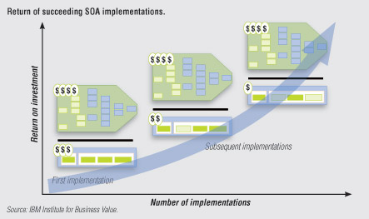
References
IBM – Service Oriented Architecture Retrieved from
http://www-935.ibm.com/services/us/index.wss/ibvstudy/gbs/a1025716?cntxt=a1002583
Ten companies where SOA implementation made a difference in 2006. Retrieved from
http://blogs.zdnet.com/service-oriented/?p=781
Measuring the value of SOA. Retrieved from
http://www.itbusinessedge.com/blogs/mia/?p=219
SOA Success: Quantifying the return on Investment of an SOA Project .Retrieved from http://www.actional.com/resources/whitepapers/SOA-Introduction/SOA-Success.html

